

American International University-Bangladesh (AIUB)  
**Department of Computer Science  
Faculty of Science &Technology (FST)  
Spring 19_20**

**Section: I  
Group No: 01**

**Blood donor finder app**

A software Engineering project submitted

By

*Muhtasim Ahmed (17-35705-3)*

*K.S Subhan Munim (18-36171-1)*

*Jannatul Ferdous Mun (18-36681-1)*

*Tanvir Rahman Tarafder (18-36894-1)*

The project will be Evaluated for the following Course Outcomes

|  |  |
| --- | --- |
| CO3: Choose appropriate software engineering model in a software development environment | Total Marks |
|  |
| Project Background Analysis (needs, goal, benefits, etc.) [5Marks] |  |
| Appropriate Process Model Selection [5Marks] |  |
| Argumentation for model selection with Evidence [5Marks] |  |
| Completeness, Spelling, Grammar and Organization of the Answer [5Marks] |  |
|  | |
| CO4: Explain the roles and their responsibilities in the software project management activities | Total Marks |
|  |
| Content Knowledge (e.g. System Requirements, System Design) [5Marks] |  |
| Project Role identification [5Marks] |  |
| Responsibility Description [5Marks] |  |
| Completeness, Spelling, grammar and Organization of the Answer [5Marks] |  |

1. **PROBLEMDOMAIN**
   1. **Background to the Problem**

Blood is one of the most important elements of human body. Blood can be defined as the fluid we have in our bodies that carries oxygen from the lungs to the rest of the body. It also carries waste to be eliminated from the body. We have between 4 and 6 liters of blood in our adult bodies depending on size. Millions of people need blood every year. There are tens of thousands of pints of blood that are needed every day to help people. Along with helping save lives, there are a number of reasons why donating blood is important. A single donation can save three lives. One blood donation provides different blood components that can help up to three different people. Blood cannot be manufactured. Despite medical and technological advances, blood cannot be made, so donations are the only way we can give blood to those who need it. Blood is needed every two seconds. Nearly 21 million blood components are transfused in the U.S. every year. Only 37 percent of the country’s population is eligible to donate blood. Your friends or family may need blood someday. In this era of technology, it’s not hard to find a blood donor but its hard to find in appropriate location and there are lots of fake groups. Therefor the purpose of the app is to simplify the process to find a blood donor

* 1. **Solution to the Problem**

Blood donor finder app is an online web-based project. Today we can easily connect with anything through internet services. So online platform is the best choice for our project. Blood donor finder app is serving for human welfare. We have all the information; patient will ever need. Many people are here who are willing to donate blood anytime for the receiver. People have to register on this app if they are willing to donate their blood when needed. Person who need to donate blood may register on our app. The person who need the blood donor, they can search and find blood donor by using this app. After searching a list of donors, they will be displayed and user can get brief details about their conduct details. So, they can communicate. The main objective is to develop a app that can create a network of blood donors, motivate more people to join and increase the number of blood donations. There has also an existing blood donation app. American Red Cross has launched a blood donor app that makes it easier for people to track their blood donations and schedule new ones. The app is available on iOS and Android devices. The Red Cross and its partners will also send the donor "thank you" messages through the app. Then NHS Give Blood app allows to book appointments and manage details on Android or Apple iPhone device. Once a person has registered to donate and set up his/her online account, he/she can download convenient and easy-to-use app. Again, there are also some Facebook group whose are working for blood donation system.

1. **PRODUCT AND PROJECT DESCRIPTION**
   1. **System Features**

List of the system functional requirements that describes the system’s functionalities are described below.

**1. System Login  
Functional Requirements**

1.1 The software shall allow users to login with their given username and password

1.2 If the username and/or password has been inserted wrong for more than three times, the random verification code will be generated by the system to retry login.

**Priority Level:** High **Precondition:** User have valid user id and password

**2. User Registration   
 Functional Requirements**

2.1 User must have to register for using this app because the app uses the user registration data for finding a donor

2.2 Name, Email, Password, Gender, Age, Blood Group, Mobile Number and Location are the information a user have to give for registration

**Priority Level:** High **Precondition:** User have to register to use this app

* 1. **System Quality Attributes**

The quality attributes that describes how well the system should perform that is given below: **Performance:** Every Web page shall download in 15 seconds or less over a 50 KBps modem connection.

**Availability:** The system has to be in its top performance for 24 hours in everyday cause blood can be needed for an emergency any time of a day.

**Efficiency:** At least 20 percent of the processor capacity and RAM available to the application shall be unused at the planned peak load conditions.

**Integrity:**Only users who have a valid access shall be able to view donor list

**Reliability:**No more than five experimental runs out of 1000 can be lost because of software failures

**Flexibility:** A valid user who have been using this app shall be able to change the data.

* 1. **System Interface**

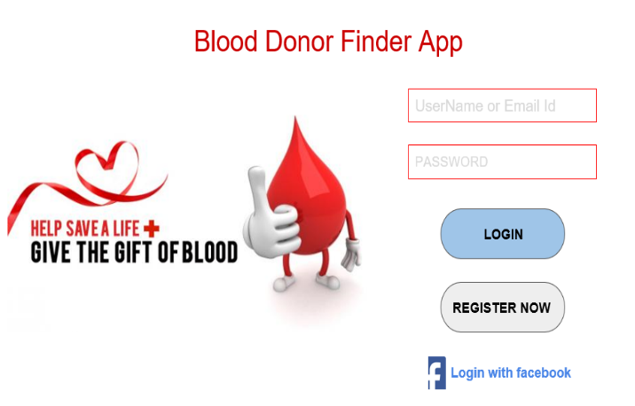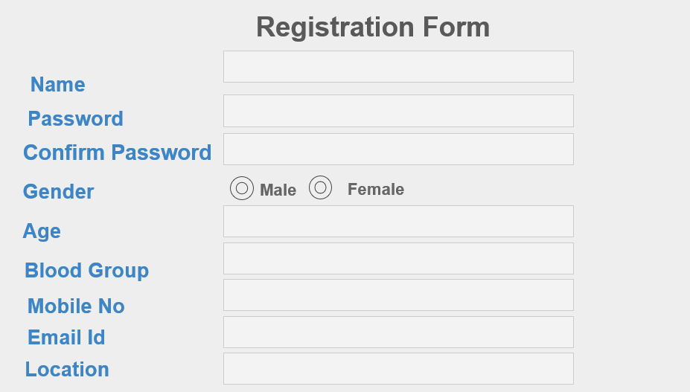

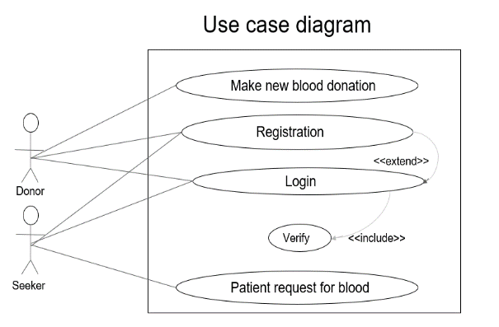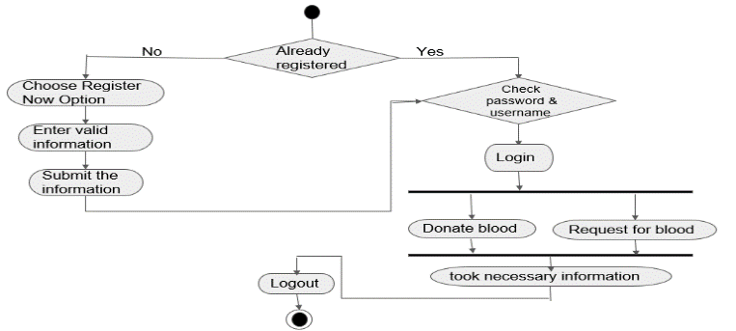

* 1. **Project Requirements**

The project contains which should be followed in the project management are given below:

* **Time:** Time is defined as the time to complete the project. Time is often the most frequent project oversight in developing projects. This is reflected in missed deadlines and incomplete deliverables.
* **Budget:** Budgetis the cost approved for the project including all necessary expenses needed to deliver the project. Within organizations, project managers have to balance between not running out of the money and not under-spending because many projects receive funds or grants that have contract clauses with a “use it or lose it” approach to project funds. Poorly executed budget plans can result in a last-minute rush to spend the allocated funds. For virtually all projects, budget is ultimately a limiting constraint; few projects can go over budget without eventually requiring a corrective action.
* **Resources:** Resources are required to carry out the project tasks. They can be people, equipment, facilities, funding, or anything else capable of definition required for the completion of a project activity.
* **Environment:**  Environment is a technical specification of requirement of software product. This specifies the environment for development, operation and maintenance of the product.
* **Scope:** Scope is what the project is trying to achieve. It entails all the work involved in delivering the project outcomes and the processes used to produce them. It is the reason and the purpose of the project.
* **Quality:** Quality is a combination of the standards and criteria to which the project’s products must be delivered for them to perform effectively. The product must perform to provide the functionality expected, solve the identified problem, and deliver the benefit and value expected. It must also meet other performance requirements, or service levels, such as availability, reliability, and maintainability and have acceptable finish and polish. Quality on a project is controlled through quality assurance (QA), which is the process of evaluating overall project performance on a regular basis to provide confidence that the project will satisfy the relevant quality standards.

**Risk:** Risk is defined by potential external events that will have a negative impact on the project if they occur. Risk refers to the combination of the probability the event will occur and the impact on the project if the event occurs. If the combination of the probability of the occurrence and the impact on the project is too high, you should identify the potential event as a risk and put a proactive plan in place to manage the risk.

**Blood donor finder app** is mainly towards people who are willing to donate blood to the patients. Through this system it will be easier to find a donor for the exact blood type and easy to build the connection between donor & the blood bank authorities. Our system encourages the blood communication between the donor and seeker.

1. **SOFTWARE DEVELOPMENT LIFE CYCLE**
   1. **Process Model**

Scrum is a framework for projects. It falls under the agile methodology and defines roles, procedures, tools, processes to make sure to deliver an efficient and effective project well on time through iterative development cycles. As per a report, there are almost 70% of the software teams who use scrum or scrum hybrid. This methodology is basically followed where there is the demand of high development process, high involvement of stakeholders. Scrum methodology repeatedly monitors software development while the project is being developed. Scrum Software Development Methodology has a major focus on the responsibility, teamwork, and iterative progress towards a well-defined business goal.

* SCRUM process includes three phases
  + Pre-game
  + Development (game phase)
  + Post-game
* The pre-game phase includes two sub-phases:

**1. Planning:**

* Definition of the system being developed
* A Product Backlog list is created containing all the requirements that are currently known
* The requirements are prioritized and the effort needed for their implementation is estimated
* The product Backlog list is constantly updated with new and more detailed items, as well as with more accurate estimations and new priority orders
* Planning also includes the definition of the project team, tools and other resources, risk assessment and controlling issues, training needs and verification management approval
  + This phase is treated as a "black box" where the unpredictable is expected
* The system is developed in Sprints
  + Sprints are iterative cycles where the functionality is developed or enhanced to produce new increments.
  + Each Sprint includes the traditional phases of software development: requirements, analysis, design, evolution and delivery phases.
  + One Sprint is planned to last from one week to one month.
* This phase is entered when an **agreement** has been made such as the requirements are completed.
* In this case, **no more items and issues** can be found nor can any new ones be invented.

The system is now ready for the **release** and the preparation for this is done during the post-game phase, including the tasks such as the integration, system testing and documentation

* **For this reason, I chose this model**
* Transparent system pushes developers to comply with their assignments and deliver it on time
* Defined deadline at every step keep developers motivated and empowered at every step
* Feedback at every level of the project ensures that quality project is delivered in the end
  1. **Project Roll Identification and Responsibilities**

**Scrum Master**

* Scrum Master is responsible for ensuring that the project is carried through according to the practices, values, and rules of Scrum and that it progresses as planned.
* Scrum Master interacts with the project team as well as with the customer and the management during the project.

**Product Owner**

* Product Owner is officially responsible for the project, managing, controlling, and making visible the Product Backlog list.
* He is selected by the Scrum Master, the customer, and the management.
* He makes the final decisions of the tasks related to product Backlog.

**Scrum Team**

* Scrum Team is the project team that has the authority to decide on the necessary actions and to organize itself in order to achieve the goals of each Sprint.
* The scrum team is involved, for example, in effort estimation, creating the Sprint Backlog, reviewing the product Backlog list and suggesting impediments that need to be removed from the project.

**Customer**

* Customer participates in the tasks related to product Backlog items for the system being developed or enhanced.

**Management**

* Management is in charge of final decision making, along with the agreements, standards, and conventions to be followed in the project.
* Management also participates in the setting of goals and requirements.

**Product Backlog**

* Defines the work to be done in the project
* A prioritized and constantly updated list of business and technical requirements for the system being built or enhanced
* Include features, functions, defects, bug fixes, requested enhancements and technology upgrades

**Effort Estimation**

* Effort estimation is an iterative process, in which the Backlog item estimates are focused on a more accurate level when more information is available on a certain Product Backlog item.
* The Product Owner together with the Scrum Team(s) are responsible for performing the effort estimation
* Sprint Planning meeting
* A Sprint Planning Meeting is a two-phase meeting organized by the Scrum Master.
* The Scrum Master, Management, Product Owner, and Scrum Team participate in the first phase of the meeting to decide upon the goals and the functionality of the next Sprint.
* The second phase of the meeting is held by the Scrum Master and the Scrum Team focusing on how the product increment is implemented during the Sprint.
* Daily Scrum meeting
* Daily Scrum meetings are organized to keep track of the progress of the Scrum Team continuously and they also serve as planning meetings: what has been done since the last meeting and what is to  
  be done before the next one.

Also, problems and other variable matters are discussed and controlled in this short (approximately 15 minutes) meeting held daily

* Sprint Review meeting
* On the last day of the Sprint, the Scrum Team and the Scrum Master present the results (i.e. working product increment) of the Sprint to the management, customers, users, and the Product Owner in an informal meeting.
* The participants assess the product increment and make the decision about the following activities.
* The review meeting may bring out new Backlog items and even change the direction of the system being built.

Product Owner, Scrum Master and Team. Product Owner is the person responsible for determining the specifications or the business of software applications to be built. Product Owner will register all the initial requirements to be done by the Team (known as the Product Backlog). Team is the one who runs the project, such as business analysts, system analysts, developers, testers and others. Team is the one who will be responsible for completing the Product Backlog provided by the Product Owner, Where the members of the team are responsible for each Backlog which has been divided as well as capable for knowing what to do next. Scrum Master is the one who set the scrum process during the project. Scrum Master will introduce and implement how Scrum works to the team and make sure everyone on the project implementing Scrum method.